The Parable of the Mustard Seed: Be pleased that our faith is evidence that when the Holy Spirit implanted the virtues of Faith, Hope and Charity in us at Baptism, we became the good soil Jesus talks about in this parable. It behooves us to remember that the fruits we bear generate new seeds. Spend those seeds to serve the people of God.

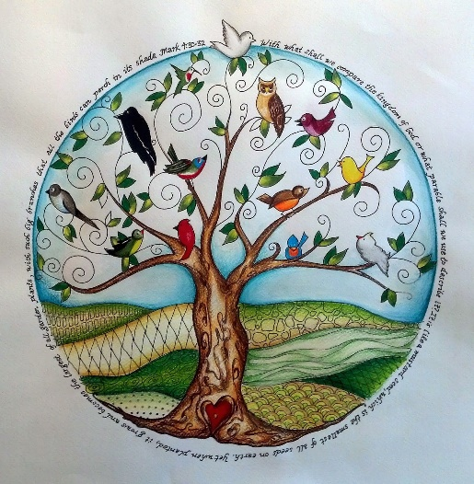

**Question of the Week: How does God’s patience with the weeds change the way I act toward others? To whom do I need to show clemency this week?**

**+**

**PRAYER REQUESTS:** A PRAYER TO PRAY FOR THE PEOPLE BELOW:

Lord, we pray for your loving support for the people listed below and their families as they deal with their illnesses. Guide the doctors who are seeking answers and making decisions about care/ treatments. We pray that their illness is at a stage favorable for effective treatment. Enable their bodies to respond well to care/treatment and their soul to experience comfort and peace in you. Make this an experience that draws them and their loved ones closer to you as well as to one another. We commit them to your mercy. Amen

Rosella Olson (Ginny Warren’s mother), , Mark Stalberger, Sherry Steffl, Ernie Clark, Martha Donley, Connie Olgaard, Deb Clark, Rick Flottemesch, , Brent Pearson, Jerry Flottemesch, Peter Pearson, Jeanine Kivi, Peg Braaten, Connie Collman Bergren, Darrell Beck, Brian Hazelton, Hali Thomas, Jim Hazelton, Chris Fairbanks, Jim Foltz, Pat Hilber (Coleen Tietz’s brother-in-law), Ken & Rita Pearson, Ethan Estabrooks , Easton Lammers (grandson of Roger and Sharon Winter), Judy Dwinell, Marlene Scherping. Jerome Jirava, Jr., Josh Janousek and Cleo Baker.

PASTOR

Msgr. David Baumgartner

Office: 218.375.3571

Rectory:218.308.1296

frdavid.shfre@arvig.net

**Secretary:**

Marlys Jacobson

Office: 218.375.3571

Home: 218.280.0760

assumptioncal@gmail.com

marlysj.shfre@ arvig.net

Office Hours:

Mondays 8:30-11:30 am

**Bookkeeping:**

Carol Zurn

218.844.3782

assumptioncal@gmail.com

**Youth Ministry/DRE:**

Kristi Foltz

Office: 218.375.3571

**Diocesan Victim**

**Assistance Coordinator:**

Cindy Hulst

Confidential Line: 218.281.7895

**Mass Times**

Thursday @ 7:00 pm

Sunday 10:30 am

**CONFESSIONS:**

Thursday @ 6:15 pm

Sunday after Mass

**ADORATION:**

Thursdays: 5:00-7:00 pm

Here is a thought from last week’s homily: *This Good News is not ours to horde and protect. It is not our job to judge who is worthy to hear it and who is not. The good news is for all!*

In my family there is a treasure chest of expertise: farming, engineering, medicine, business, transportation, risk management, city infrastructure, university systems, theology, law and education. When we get together, we are more interested in talking about our family heritage and history than insurance and banking.

Jesus called to people from every area of life. They set aside their expertise and became disciples of a carpenter who was the son of carpenter. Jesus did not teach them about wood and stone; he taught them about the kingdom of God. Eventually this became the family heritage and history of the apostles and disciples—to understand that we are children of God and that everything else on earth is at the service of faith.

Somethings serve earthly kingdoms; somethings serve the kingdom of heaven. A challenge for Christians is to remember the purpose of work is to support and serve the family and that the family is the first and most important school for holiness.

*“The kingdom of heaven may be likened to a man who sowed good seed in his field…He who sows good seed is the Son of Man, the field is the world, the good seed the children of the kingdom.”*

*(Matthew 13:24, 37-38)*

As children of God, we are all “good seeds.” We are blessed by God with the potential to accomplish much good in the world. We fulfill God’s plan when we spend time in prayer every day, use our skills to help others, and share our financial gifts to help build God’s kingdom on earth. Through our example of gratitude and generosity we sow “good seeds” on earth and ultimately help each other get to heaven.

**Sunday, July 12, 2020--$1,371**

**Peter’s Pence--$133**

**Mass Intentions**

**Thurs., July 23: For Marriage and Family Life**

**Sat., July 25: For the People of Assumption**

**and Sacred Heart parishes**

**Sun., July 26: +James & Grace Fairbanks**

The Pastoral Council has decided to cancel the Fall Dinner and Raffle for this year.

**Ministry Schedule for July 26, 2020**

**Saturday Sunday**

**Lector**

*Bill Steffl Al Foltz*

**Usher**

*David Steffl Rick McDougall*